07/2016

ATV61 on Modbus TCP/IP to M580

Introduction

This document describes a basic M580 application communicating via Modbus TCP/IP with the ATV71 - equipped with
VW3A3310D card.
M580 is I/O scanning ATV61 using DTM ‘s.
A detailed functional description or the specification for a specific user application is not part of this document.

Intention was to deliver a kind of ‘quick start-up guide’ for the mentioned set of devices.

Application was developed with Unity version 11.0 and SoMove 2.5.3.0.

Network scheme

VW3310D card inserted into ATV61 is connected directly (point-to-point) via Ethernet patch cable to service port of BMXP582040

Communication & control via network principles

M580 master DTM is I/O scanning ATV61– Unit ID =255
Drive is controlled via inserted Vw3310D card, using I/O profile.

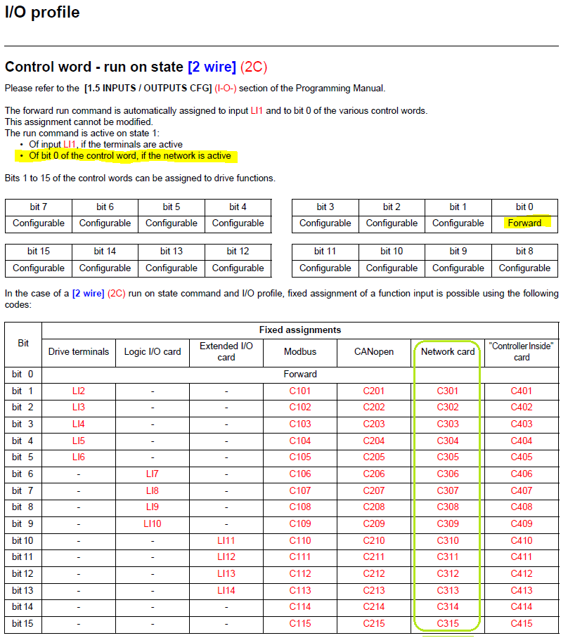

ATV61 Configuration

- Perform factory settings for the drive,
- Necessary drive configuration changes after factory reset:

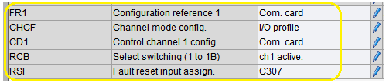

- Necessary VW3310D card configuration:

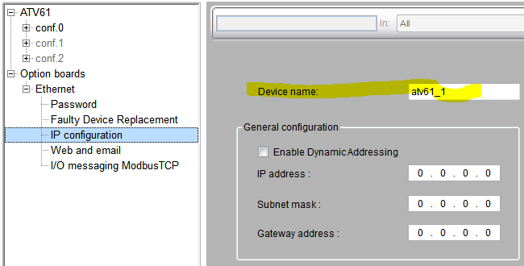
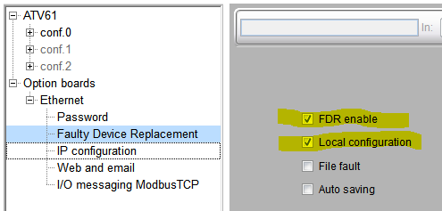

Default I/O scanner content is sufficient to have the basic drive’s control so, we left I/O scanner as it is:

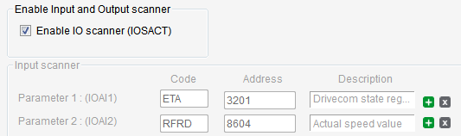

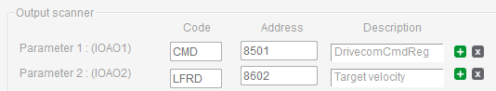

M580 program

The complete drive’s configuration and detailed step-by-step M580 program creation are recorded on the attached MP4 video file.
Both Unity files and SoMove project are attached.

FILES:

